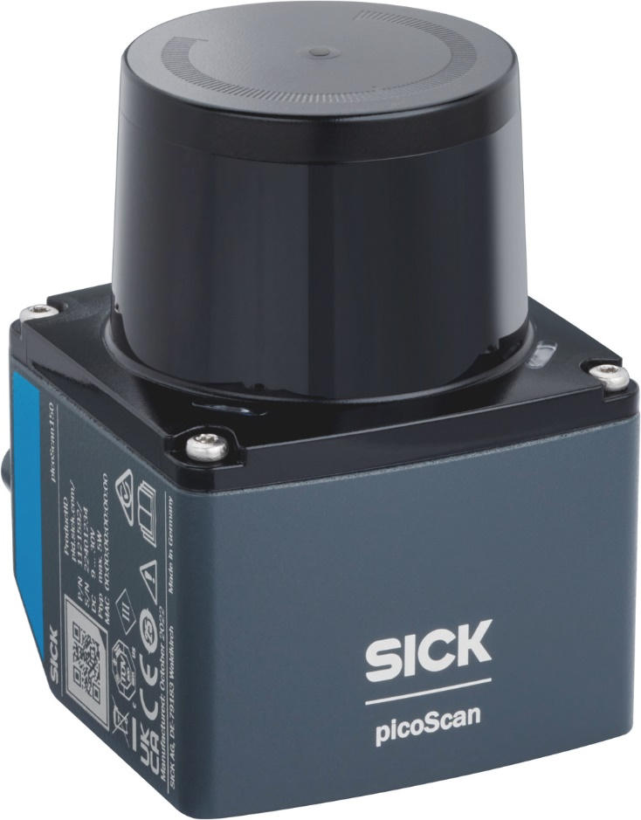

The August 2025 list price for the picoScan100 is $5,227

